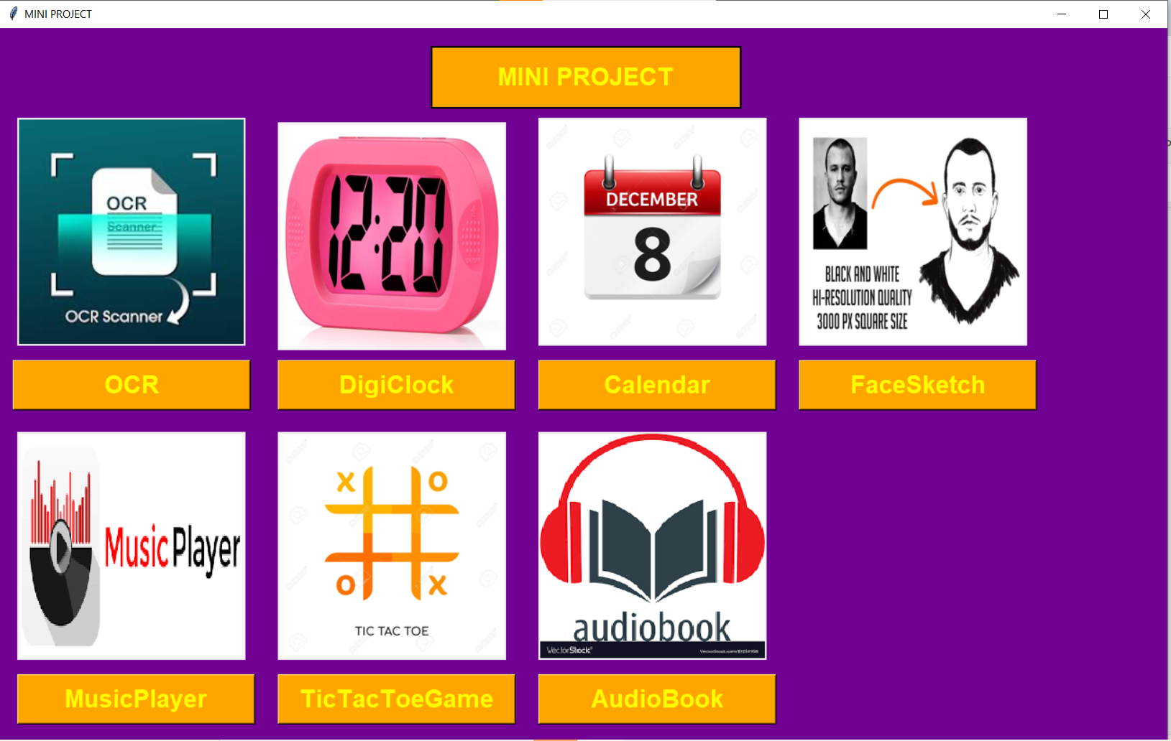

OCR:

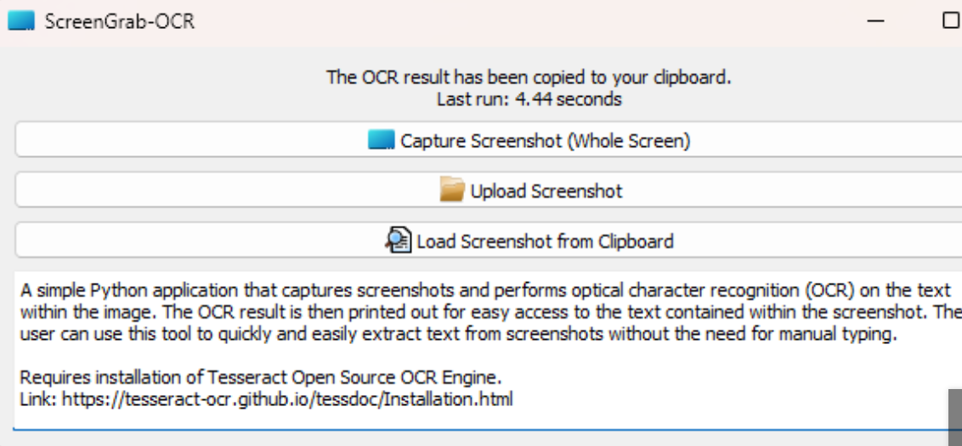

DigiClock:

Calendar:

Pencil Sketch:

Tic Tac Toe:

